Rick Gaudette
January 20, 1998

Computational Electromagnetics Project Proposal

Propagation of electromagnetic energy in a highly scattering medium such as biological tissue is extremely difficult to describe using Maxwell's equations as a starting point. Another approach has been to combine conservation of energy properties with the statistical scattering behavior of the medium of interest. This approach yields a linear transport equation to describe photon propagation within the medium. One form of the this equation is

.

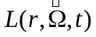is the radiance at position r, traveling in the direction 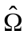, at time t. 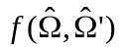 is probability of scattering into a direction 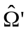, from . is the speed of propagation in the medium, 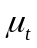is the total interaction coefficient and 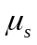 is the scattering coefficient. Even this equation is difficult to solve for L() given the spatially varying integro-differential equation. By making a number of assumptions the light behavior can be approximated by an equation similar to the heat diffusion equation. This is given by
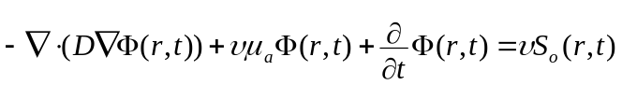.
Where is the spatial varying diffusion coefficient. 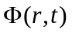is the photon fluence and 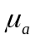is the absorption coefficient. This is a reasonable approximation when 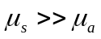, such as this case in some biological tissue (e.g. skin and dermis).

Recently there has been substantial interest in the ability to model this type of light propagation to be able to perform non-invasive biological detection and imaging using lasers at infrared wavelengths. Since one of the parameters of interest to image is the scattering coefficients of the tissue my proposal involves examining the behavior of light in a non-homogenous medium. Some basic (although not simple) work has been done in modeling spheres of one scattering coefficient in a medium of a different scattering coefficient. I propose to recreate this work as well as try to extend it to non-uniform grids. This might help reduce the computation complexity by placing more computational emphasis at the boundary regions where quantities may be varying in a more complex manner.

References:
Diffuse Photon Probes of Structural and Dynamical Properties of Turbid Media. Boas, David A., Ph.D. Dissertation in Physics, Univ. of Pennsylvania, 1996

Wave Propagation and Scattering in Random Media. Ishimaru, Akira, IEEE Press, New York, 1997

Efficient computation of time-resolved transfer function for imaging in turbid media, Dunn, Andrew, DiMarzio, Charles, Journal of the Optical Society of America, Vol. 13, No. 1

